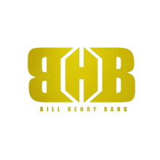
BHB OFFER FORM

Event Date:
Event Times:
Doors open:
Performance Time:
Number of Shows:
Length of Performance:
Event Type/Description:
Is BHB the Headliner:

Venue Information
Venue Name:
Venue Address:
Venue City:
Venue State /
Venue Zip / Postal Code:
Venue Country: USA
Venue Phone#
Venue Type:
Venue Capacity:

Purchaser Information:
Offer Made By (Contact Person Name)
Purchaser Organization or Company Name:
Purchaser Address:
Purchaser City:
Purchaser State /
Purchaser Zip / Postal Code:
Purchaser Phone#
Purchaser Email:
Purchaser Website:

***WHEN FINISHED, CLICK FILE > ‘SAVE AND SEND’ TO BILLHENRYBAND@GMAIL.COM***

Offer expires: 2 Days after submitted

This offer is made pending a final agreement in writing between the Band and the Purchaser.
Upon acceptance of the offer by the Band, the Purchaser agrees to return signed contracts and riders to the Agent immediately upon receipt by the Agent, and agrees to abide by all terms and conditions of the contract and this offer.

